# CSCD 434 AWS Lab 4 – Local DNS Attack

## Task 1.1

I believe the IP address will be 10.9.0.153 as that is the address listed in the document’s network map.

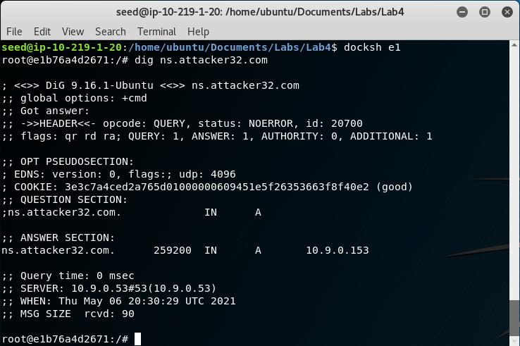

## Task 1.2

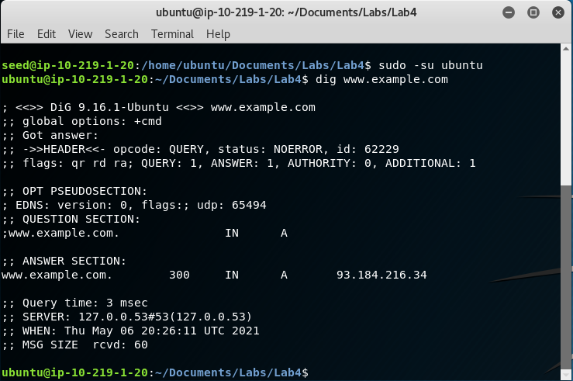

## Task 1.3

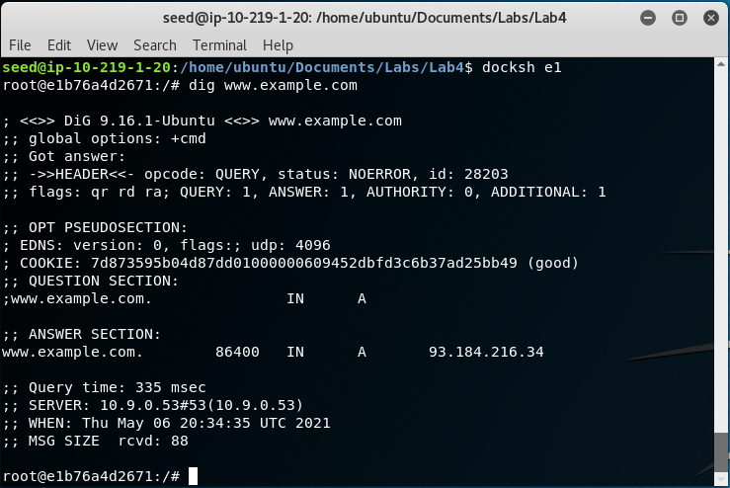

## Task 1.4

Without any context for the command, I would assume the IP address would be the same 93.184.216.34 as before, or something in the 10.9.0.x network.

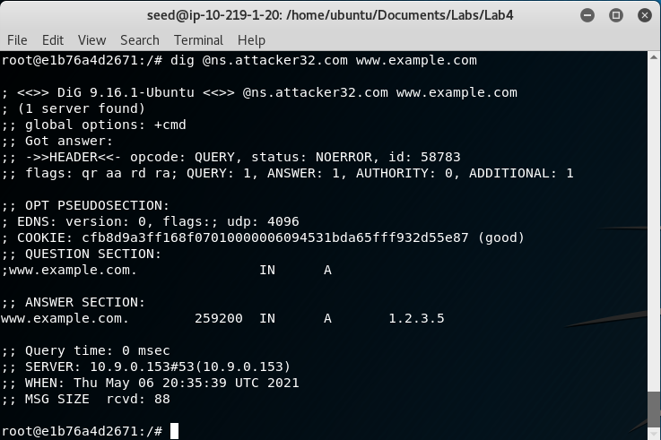

## Task 2.1

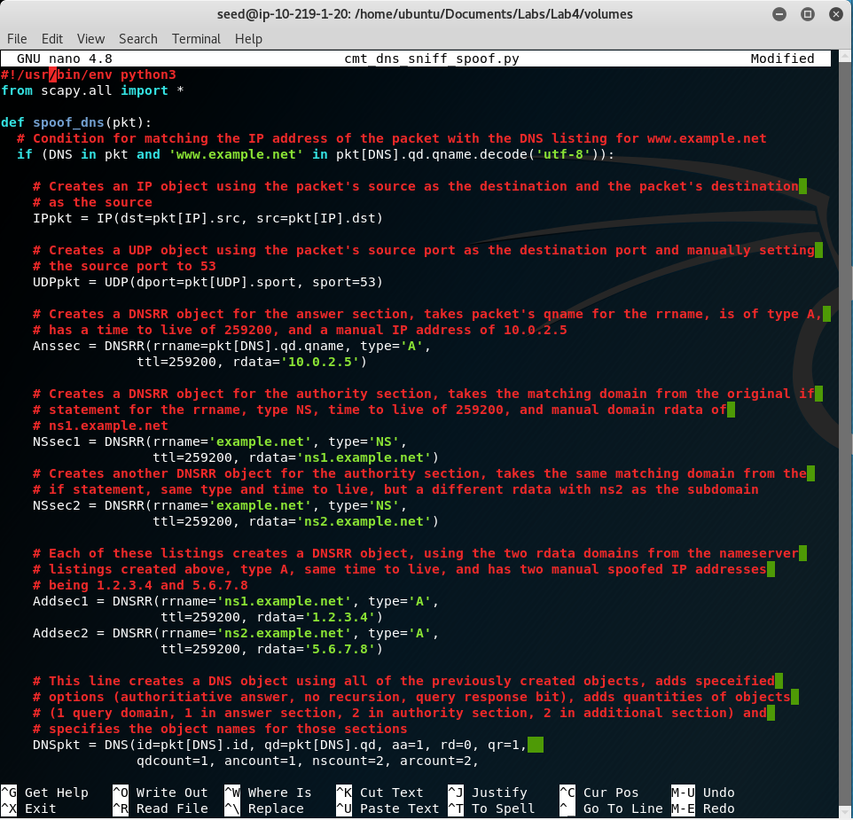

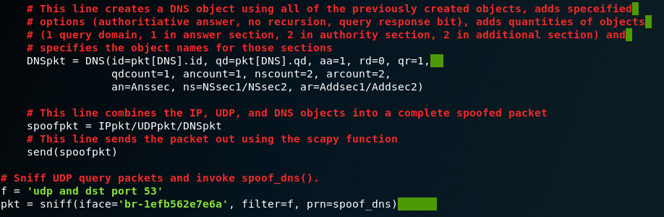

## Task 2.2

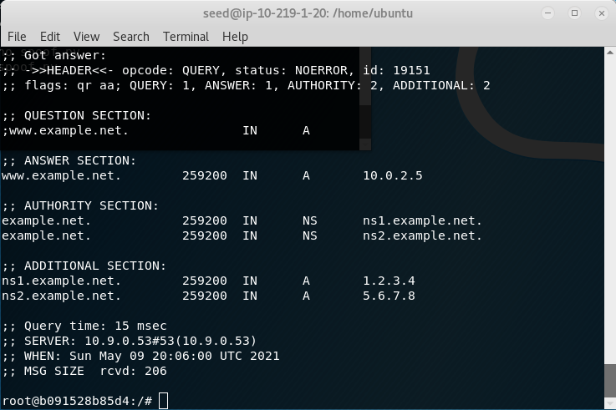

The spoof.py script prints a line that states “Sent 1 packets.”

## Task 2.3

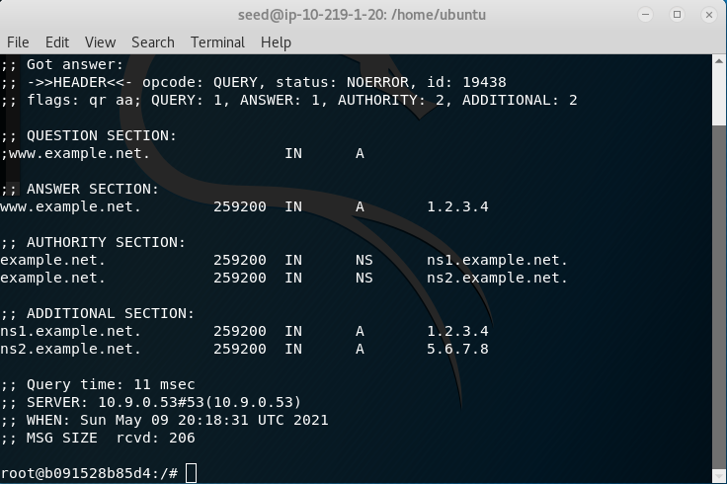

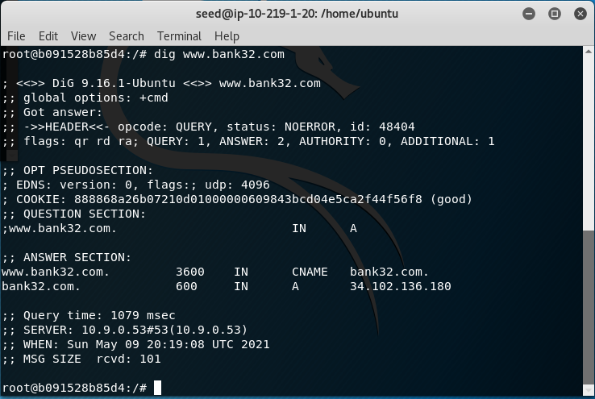

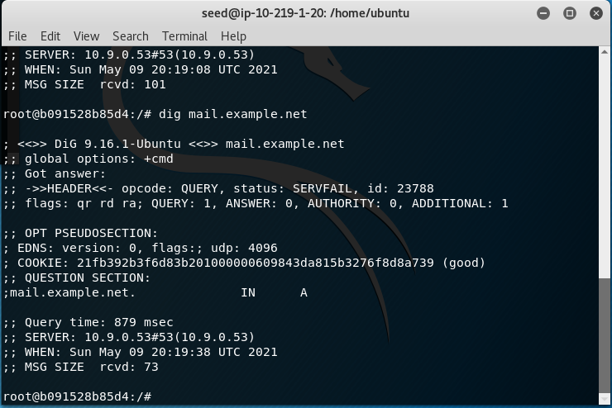

## Task 2.4

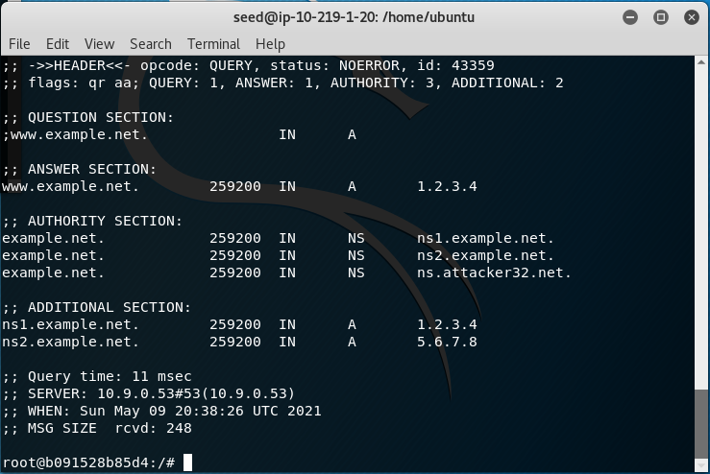

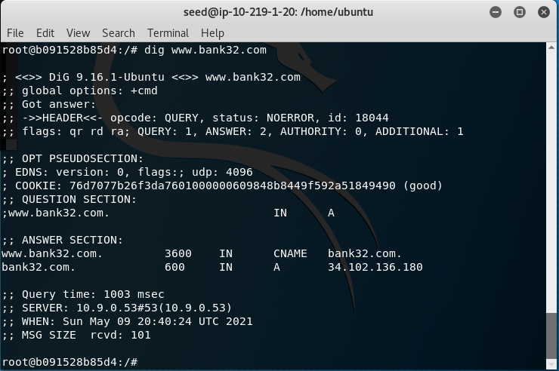

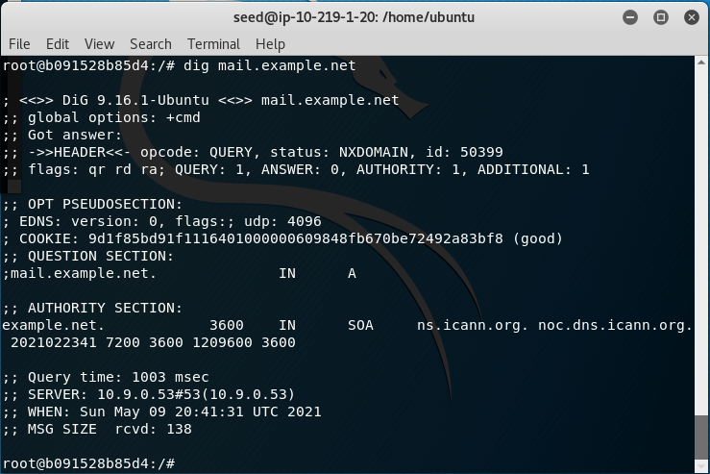

The seed attacker container showed a “Sent 1 Packets” statement for the first query given.